Siebel Core Developer and Technology School
Participant Guide

Table of Contents
Table of Contents 2
Siebel Core Developer and Technology School 3
Overview 3
High-level Learning Goals 3
Course Objectives 3
Prerequisites 3
Part I: School Design 3
Part II: Continuous Learning 3
School Materials 3
School Map 3
Your Role 3

Siebel Core Developer and Technology School

Overview
The Siebel Core Developer and Technology School is comprised of three phases:
- Prerequisites which must be completed prior to attending the School
- Part I is a 8.5 day hands on school experience
- Part II is a group of virtual/self-paced training materials
Part I is designed to prepare you for your role as Configurators and Technical Architects on Siebel engagements. The School, along with the materials in Part II, will provide you with the knowledge and materials to successfully pass the Siebel Core Consultant Certification Exam. It is required that both Part I and Part II be completed to mark this course complete.
All school materials are available for download from the Siebel Core Developer and Technology School web site.
Live classroom presentation and discussion, with the faculty positioned in the role of a coach, revolves around components and installation of the Siebel 7.7 Technical Architecture.

High-level Learning Goals
- Prepare new developers for their first role as a Siebel Configurator.
- Introduce technical architecture concepts to Configurators and Siebel Technical Architects.
- Provide a functional and technical introduction to Siebel 7.7.
- Enable participants with the necessary skills and knowledge to configure the standard Siebel 7.7 application suite.
- Prepare participants to take the Siebel 7.7 Core Consultant Certification exam.

Course Objectives
After completing this course, you will be able to:
- Introduce the Siebel product suite
- Navigate the Siebel eBusiness user interface
- Describe the Siebel eBusiness architecture
- Install Siebel eBusiness software to set up an enterprise
- Secure access to Siebel applications and data
- Define a company structure
- Configure a Siebel eBusiness application
- Populate and manage data into the Siebel database
- Automate business rules in a Siebel eBusiness application
- Understand Siebel Methods
- Understand Accenture’s Testing Strategy
- High light external and internal resources available

Prerequisites
Prior to attending the School, you should have completed the following prerequisites:
- Relational Principles – 12 hour online self-study
- SQL Programming: Database Queries – 4 hour online self-study

Part I: School Design
Siebel Core Developer and Technology School is comprised of 53 modules. The majority of the modules taught during the School include labs, which will allow you to engage in hands-on practice of what you have been taught.

Part II: Continuous Learning
Your learning experience is not complete when the school is over. It is important that you complete the virtual, self-paced materials in Part II. These materials can be found on the myLearning.com website - course # Z20148- Siebel Core Developer and Technology School (Part II): (https://mylearning.accenture.com/asp/LMSLink.asp?file=catalog/activity.jsm&ID=32625). You must complete Part II in order to mark the course complete.
Part II consists of the following:
- Siebel Methodology - Implementing Siebel Solutions
- Siebel Case Study – must be completed prior to certification
- Practice Exam
- Siebel Consultant Certification Exam Guide
Note: The first module, Siebel Methodology: “Implementing Siebel Solutions” is Siebel’s recommended methodology and should ONLY be reviewed and learned for the certification exam. However, for projects, we recommend you follow the Accenture Siebel Methods which will be covered during the school.

School Materials

Presentations
All school materials are available for download from the Siebel Core Developer and Technology School web site:
https://tsamr.accenture.com/sites/Siebel%20Core%20Developer/default.aspx
You will receive access to the school website during the course. You may want to print modules such as Resources and Methodology for reference. If you would like to download/print any materials, please access the school website within 1 month after you attend the course as afterwards you will lose access to the site.

Labs
All school labs (including worksheets and instructions) are included at the end of the guide.

School Map

Week 1
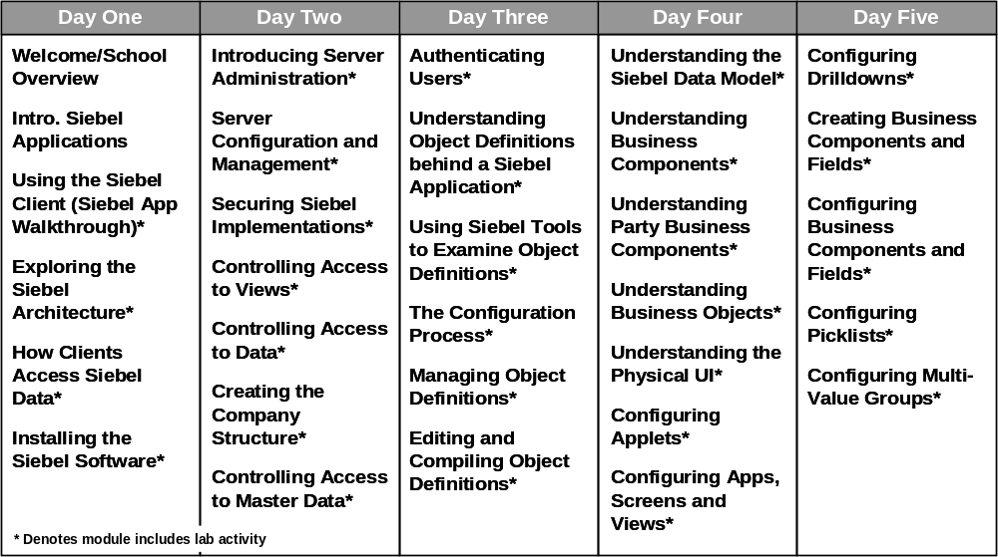

Week 2
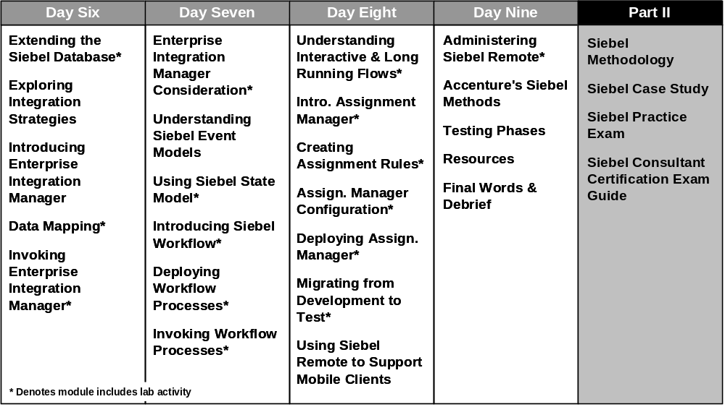

Your Role
As a participant in the Siebel Core Developer and Technology School it is critical that you immerse yourself in the content. In order to learn new skills you need to be an active and engaged participant in all lectures and lab activities. Please keep all client work or meetings commitments after school hours, or during scheduled breaks.

